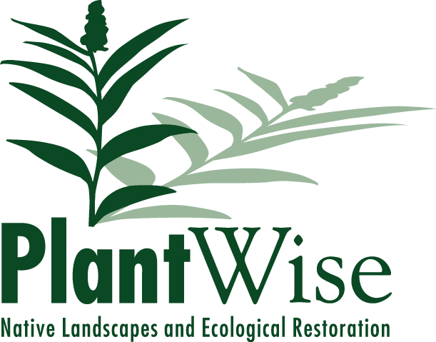

2015 Ecological Restoration
Grant Opportunity

PlantWise, LLC is excited to offer an in-kind grant of our services, valued up to $5,000. We plan to complete this project during the 2015 calendar year.

Applications are due by March 30, 2015.

Please submit completed applications electronically to:

info@plantwiserestoration.com, with the subject header “Grant Opportunity”

Mailing address (if needed):

Attn: Grant Opportunity
PlantWise, LLC
646 Barber Ave.
Ann Arbor, MI 48103

Grant Objectives:
The grant can be used for any of the type of services we typically offer, including invasive plant control, prescribed burning, native landscape installation, or botanical inventories. The grant is intended to provide our services, or a combination of our services and materials. It is not intended to provide material purchases only. Please see our website, www.plantwiserestoration.com, if you have any questions about the types of projects our company completes.

Examples, to provide a sense of what $5,000 might typically cover:

- Burning a 50-acre prairie planting.
- Control of woody invasive plants over 5 acres of lightly infested woods.
- Design and installation of a 1,500 square foot rain garden.
- A small living roof.
- Several raised garden beds and a small orchard.
- Turning an acre of lawn into prairie.
- A complete botanical inventory and management recommendations for a natural area.

We require that:

- the project be located within an hour’s drive of our Ann Arbor location;
- the applicant be a non-profit or has an educational or environmental mission;
- the applicant has the commitment, skills and resources to maintain and build on our work;
- the project is within our skill set and that it is feasible to complete within the budget and time allotted;
- the applicant has long-term control of the land in question;
- the applicant recognizes our contribution to their mission with their membership/site users in some way.

Proposed project elements that we’d like to see:

- your contribution to the project/work in some form;
- a significant environmental or educational benefit;
- a focus on sustainability;
- public access to the project site, particularly in an under-served area;
- and last but not least, a project that is creative, interesting, challenging, and fun!

While the above are guidelines for a successful proposal, PlantWise, LLC reserves the right to award or not award the grant, and choose the awardee, at our sole discretion, and for any reason.

Name of organization:

Address:

Website:

Contact person:

Phone number:

Email:

Briefly describe your organization’s history and mission:

Project location:

Include a biography or brief resume of key personnel or the project lead we will be working with:

Please provide your envisioned narrative for the project. Include the purpose of the project, the needs that it fulfills, goals and anticipated uses/results, and any contribution you will be making to the completion of the project (planning, labor, materials, site preparation, etc):

Please describe your organization’s future plans for the project and the maintenance that you will provide to ensure it’s continuing success. Include details of funding and staff/volunteer labor available, evidence of past successes, and in general describe the organization’s capabilities to maintain or build on our efforts:

Please describe how PlantWise will be recognized by your organization:

Is there anything else you’d like us to know about your organization and/or the project?

Please attach or include any maps, drawings, or photographs that illustrate your planned project and will help us to understand the scope and location of the project.

Completed By:

Date:

Signature:

