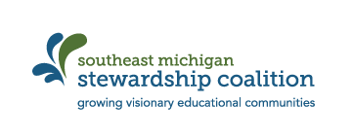

Place-based Education Stories to Share
Share a story of student impact from the past semester. Include any student quotes, interactions, and/or formative assessment information that you remember that indicated that the experience was powerful for the student.

# of students engaged in PBE the 1st semester |  | # of students you expect to work with in the upcoming semester  New? Or Same as 1st semester?
Estimate # of hours of meaningful watershed experience | Estimate # of hours spent out in the community |  | Estimate # of hours spent in the classroom preparing for a PBE experience
Share a meaningful watershed experience from the past semester. If none, share upcoming plans…

******PLEASE TURN THE PAPER OVER ******
Share a meaningful community experience from the past semester. If none, share upcoming plans…

Share a meaningful classroom experience that supported PBE from the past semester.

Is there a challenge to untangle in the new year that the Coalition can help you with?

If so, how can the Coalition help?

