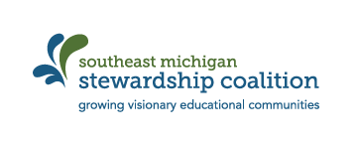
Sharing Our Stories

Please share your story of SEMIS work so far this year:

Who is involved? (Community partners, number of students, other teachers)

Main project description –

What activities have been done so far?

What outcomes do you have for students’ learning as a result of the work?

What community issue or need is addressed through this work? How was the issue chosen?

How is this project encouraging behaviors and thinking in your students that show they are becoming stewards of their community and environment?

Can we feature your program in the Common Room? On Facebook? As a Case of Powerful Place-Based Education in our Shared Stories?

If so, please send us pictures or video.

Do you need help to tell your story? We can do a 10 minute interview with you to help you articulate your work.

