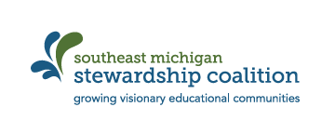
Powerful Questions for Planning
There will come a point in developing a PBE experience when you feel stuck, or just feel like something is missing. Whether it’s where to begin, how to proceed, or what to add for next year, sometimes a well-timed question can add a new perspective to a PBE plan. Below is a list of questions that you might focus on when you are feeling stuck or need a jump start in planning.
- What are my learning goals for this project?
- What assessments will I use to determine student learning?
- Have I provided opportunities for student driven inquiry, investigation and choice in this work? How can I help my students develop voice through this experience?
- What deep partnerships can we develop in the community to help us investigate and address the issue at hand?
- What opportunities are there for inter-generational dialogue between my students and community members?
- What is the social and ecological issue here? How can I help students to explore and understand the root causes of the issue?
- What are the policies or practices that affect your issue?
- How can this work impact the social and ecological health of the community?
- What evidence do we need to gather, and how can we analyze it and present it, in order to affect change in the community?
- What opportunities are there for students to develop a deep relationship with the more than human world (e.g., “nature”)?
- How will this help my students develop a better understanding of and connection to the Great Lakes?
- What historical perspective is represented in my project?
- How can we integrate the arts and EcoJustice into this work

